INTRODUCTION TO STATISTICS AND COMPUTATION WITH DATA: Homework 1
Daibik Barik
BMAT2316
(1)
Trial | Outcome of roll 1 | Outcome of roll 2 | Outcome of roll 3 | Outcome of roll 4 | Outcome of roll 5 | Y: Sum of rolls
1> | 4 | 2 | 1 | 6 | 2 | 15
2> | 5 | 2 | 2 | 3 | 3 | 15
3> | 6 | 4 | 6 | 4 | 4 | 24
4> | 3 | 4 | 5 | 1 | 5 | 18
5> | 1 | 1 | 3 | 1 | 4 | 10

(2) Output:
(a)
> instasee= c(8,8,3,12,13,10,1,8,7)
> timediff= diff(instasee)
> timediff
[1] 0 -5 9 1 -3 -9 7 –1
> x= timediff%%24
> x[1]= 24
> x
[1] 24 19 9 1 21 15 7 23

(b)
> max(x)
[1] 24
> min(x)
[1] 1
> mean(x)
[1] 14.875

(3) Output:
(a)> scoreSS=c(7,6,10,8,7,9,9,6,4,10,8,6,9,10)
> max(scoreSS)
[1] 10
> min(scoreSS)
[1] 4
> mean(scoreSS)
[1] 7.785714
(b)
> scoreSS[4]=5
> mean(scoreSS)
[1] 7.571429
(c)
> sum(scoreSS>=9)
[1] 6
(d) The number of elements in the vector which are greater than or equal to the numeric value of 9. As all the scores are less than 17, we say our answer to be 100%.
> sum(scoreSS<17)/length(scoreSS) *100
[1] 100

(4) Output:
(a)
> Shreelakshmibill=c(460,330,390,370,460,300,480,320,490,350,300,480)
> sum(Shreelakshmibill)
[1] 4730
(b)
> max(Shreelakshmibill)
[1] 490
> min(Shreelakshmibill)
[1] 300

(c)
> sum(Shreelakshmibill>400)
[1] 5
> sum(Shreelakshmibill>400)/length(Shreelakshmibill)*100
[1] 41.66667

(d)
> freemoney=3000-Shreelakshmibill
> mean(freemoney)
[1] 2605.833
(5) Output:
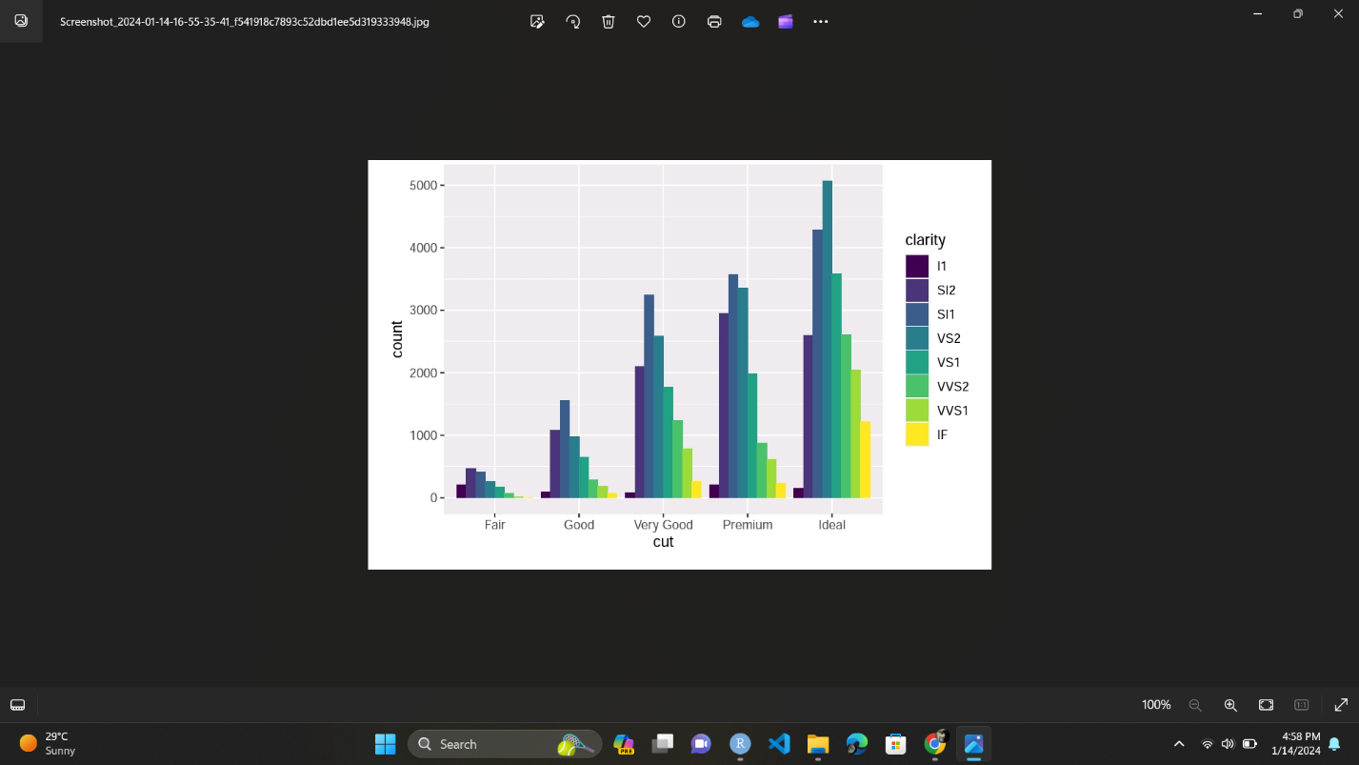
(a)
A dataset containing the prices and other attributes of almost 54,000 diamonds.
Has different variables like price, carat, cut, color, depth, clarity, x, y, z, table.
(b)
> library(tidyverse)
> library(viridis)
> ggplot(data=diamonds)+geom_bar(mapping=aes(x=cut,fill=clarity),position="dodge")+scale_fill_viridis_d()
(c) As the cut progresses from far to ideal, the average count of all the clarities increases. This can be observed from the height of the histograms along the Y-axis.

